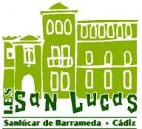

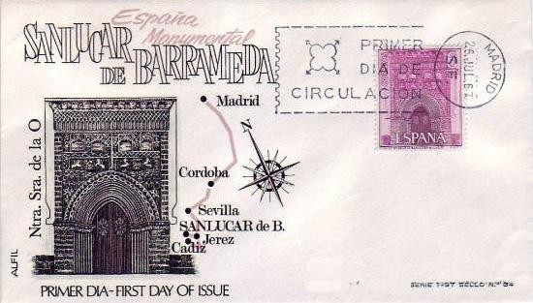
WORKBOOK:
ERASMUS +
School years: 2020/22

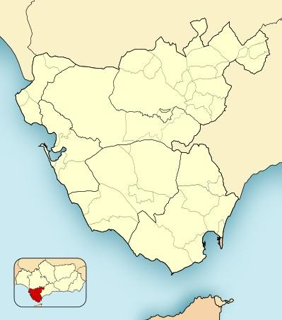

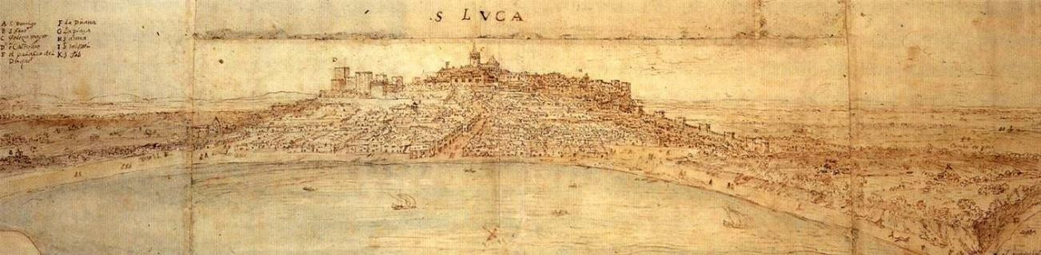

WELCOME!

We are located at the mouth of the Guadalquivir River, a strategically privileged area that has been inhabited since prehistoric times. The origin of the town dates back to the Islamic period, when a castle was built in the upper area to defend the entrance to the Guadalquivir from attacks by Norman pirates ("Vikings"). During the 13th century, the support given to the Castilian kings, in the defence and pacification of the area by the Pérez de Guzmán family, made them obtain multiple privileges such as acquiring the ‘Lordship of Sanlúcar’ or the ‘Duchy of Medina Sidonia’.

After the discovery of America, Sanlúcar acquired great development due to the commercial activity of its port. In the middle of the 17th century the city began to decline due to the transfer of the American commercial axis to the Bay of Cadiz.

Nowadays, Sanlúcar is one of the most important towns in the province of Cadiz because of its great fishing and wine making activity. Its historical past is reflected in its rich heritage and its many wineries are testimony to its main economic activity today.

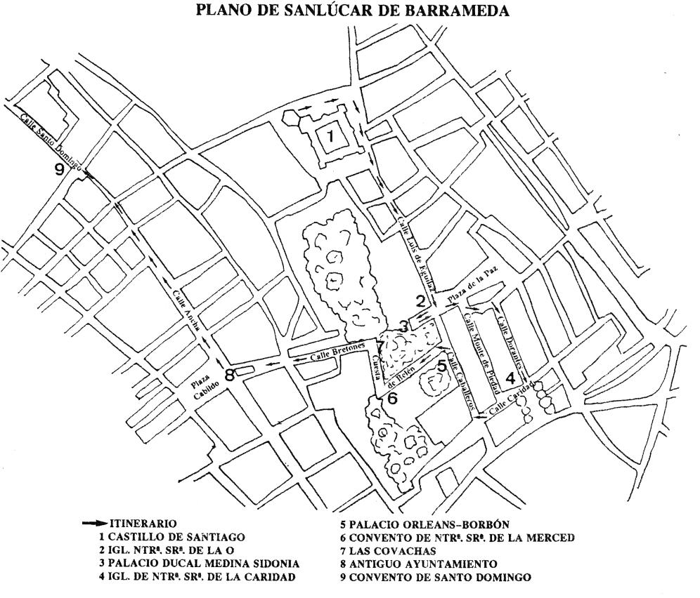
Comentario [Lac1]: Actualizar mapa con itinerario mas claro

STARTING POINT OF THE ROUTE CABILDO SQUARE) TOWN HALL SQUARE
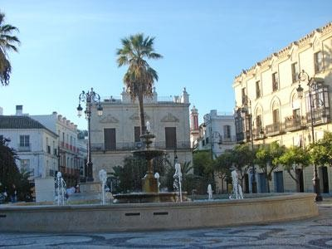

For years it housed the town hall, from which this central square takes its name and is now a meeting place for many Sanluqueños. In it, there are stately buildings that reveal in their facades the desire for perpetuity of great noble families enriched by the American trade. Today many of them have unfortunately been lost.

As a curiosity, the four palms that you can see date back to 1894 and were brought from the garden of the Count of Niebla. It was planned to erect a

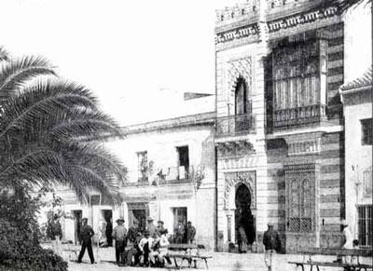
Antiguas viviendas en la plaza del cabildo.

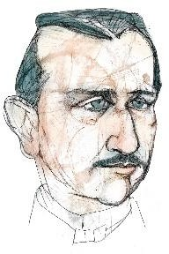
statue of the artillery brigadier from Sanlúcar de Barrameda, José González Hontoria, the inventor of the cannon system named after him, but the decision was never made.

Me quedé sin mi estatua…

In 1724, the construction of a "bakery to sell such an essential food as bread in a clean and safe place" and a "chapter room, with its corresponding interior decoration and the exterior for public functions", were authorized.

In one of the rooms of the old Town Hall there is a plaque that reads as follows: "REINATING THE MAGESTY OF THE LORD DON PHELIPE V AND BEING THE POLITICAL AND MILITARY GOVERNOR OF THIS CITY THE BRIGADIER D. FRANCISCO ...........

You can go into the old town hall and write in this notebook what is left of the sentence.

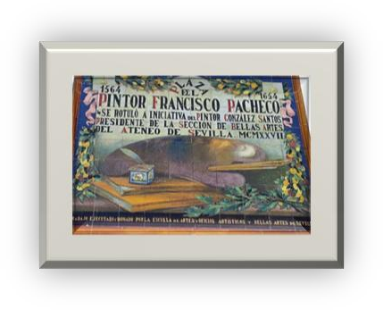
When you leave the town hall you will have to look for this tile plaque that speaks of a famous painter from Sanlúcar. You will have to write down his name since he is the author of the next stage.

Then you have to go down Ancha Street until you reach the church of Santo Domingo.

THE CHURCH OF SANTO DOMINGO

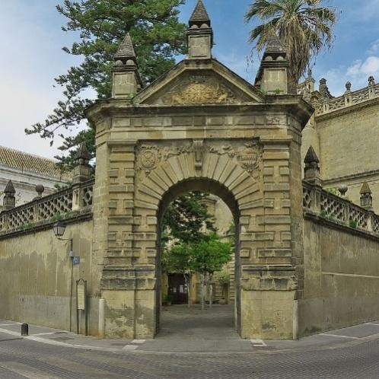
It belonged to the former convent of Santo Domingo and was founded in the first half of the 16th century by the 5th Duke of Medina Sidonia, Alonso Pérez de Guzmán y Zúñiga and his wife, Ana de Aragón. However, its construction was carried out later, between 1558 and 1570 at the expense of the Countess of Niebla who, together with her husband, Juan Claros Pérez de Guzmán y Aragón, are buried in the main chapel of the temple.

For its construction, a place in the Lower Quarter of the city was chosen, outside the citadel, called at that time the
Arrabal de la Ribera and which, since the beginning of the Modern Age, had experienced great urban development.

The church is made of stone masonry following a Renaissance style with many Mannerist elements such as its doorway, formed by a semicircular space flanked by bolstered pilasters on which there is a triangular pediment topped with simple pyramids on Escurial balls.

The floor plan is a Latin cross inscribed within a rectangle, and is composed of a single nave with side chapels that communicate with each other through small gaps between the walls that separate them. The transept is covered with a high dome on pendentives with an octagonal base. Both the sides of the transept and the chancel are covered with elegant vaults decorated with coffers and very classical motifs.

In the first section of the feet is the choir, built on a vault of coffers whose decoration includes the coat of arms of the Pérez de Guzmán family and reliefs with images of the defence of Tarifa by Guzmán el Bueno.

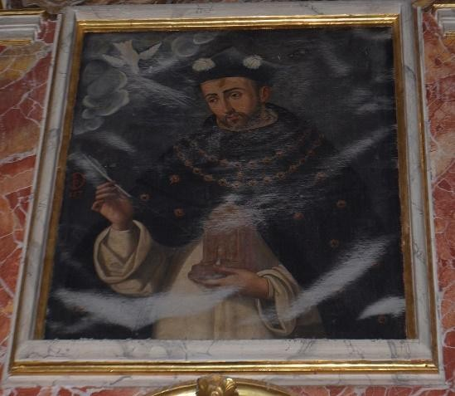
This work represents the person church is dedicated to, the founder of the Dominican order. Would you be able to find his location within the church?

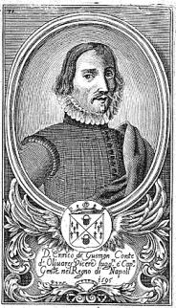
THE CASTLE OF SANTIAGO
Built by Don Enrique Pérez de Guzmán, II Duquede Medina sidonia, at the end of the 15th century, it is one of the best documented and largest castles. Coinciding with a moment of family economic splendour, the Duke undertook the construction of this imposing fortress, which was completed in 1477.

Many historical figures have stayed here, such as Queen Isabel la Católica, who is said to have seen the sea for the first time from one of the windows, or Christopher Columbus, before setting off on his third journey to America.

CASTLE'S FLOOR PLAN
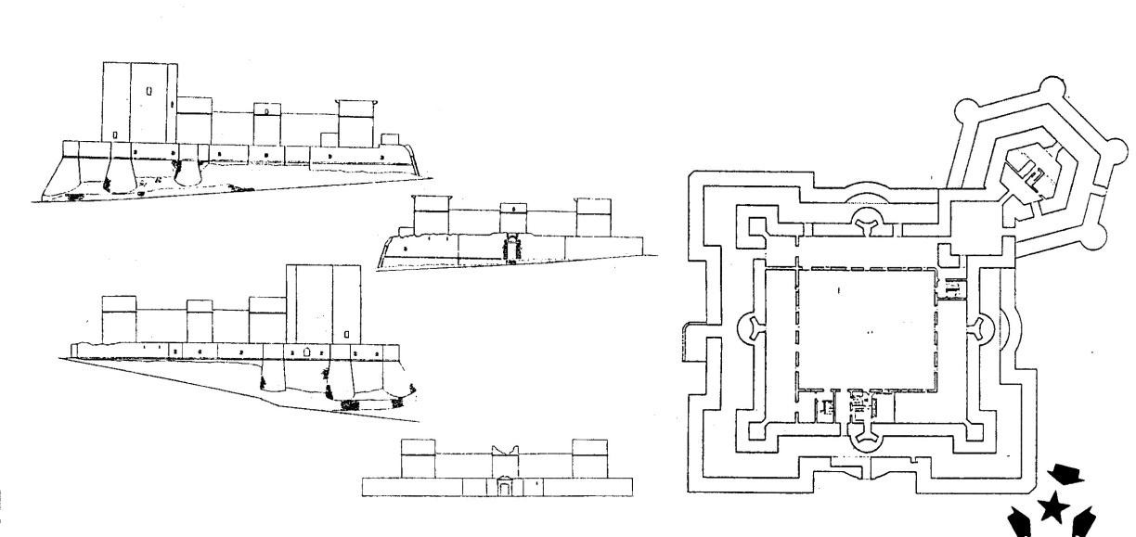

We begin the route in the square where the CASTLE OF SANTIAGO (15th century) is located, in one of the corners of the medieval walled enclosure, which we cannot see because it has partly disappeared or is hidden between the houses.

Stand in front of the castle at the point marked on the map and look at its solid walls in keeping with its defensive character. Several techniques were used to build them. Mark those that you identify from among the proposed models:
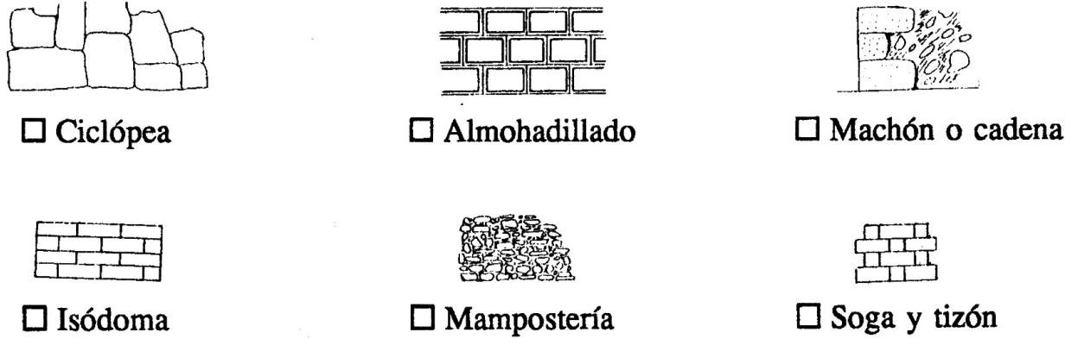

In its angles, square towers stand out, and in the central area of its walls there are circular ones. Which of these definitions of its function do you think is more accurate?
- to decorate the facades.
- to attack the enemy better when he approaches their walls.

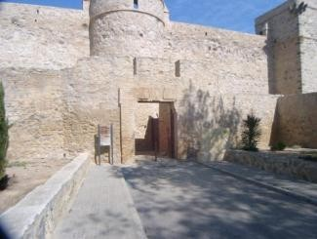
GATE OF SANTIAGO

The Castillo de Santiago was originally accessed through the door called de la Cava or de Santiago, as it housed a sculpture of this apostle (now disappeared) which probably decorated the lintel of the door and which would give the name to this fortress.

From the 18th century onwards, the side door of the wall was opened, which is still used today to access the parade ground.

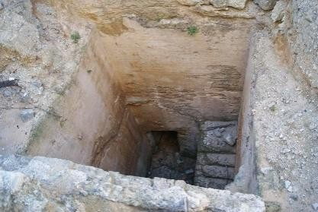
THE PASSAGEWAY

The castle of Santiago remained in continuous use until 1645, when it was confiscated by the crown due to the attempted rebellion of the IX Duke, Don Gaspar Pérez de Guzmán. This underground gallery, connecting the castle with the ducal palace, and designed to provide a quick escape route if necessary, in
those years of uncertain future, is preserved from this period.

BARBICAN

The castle has a powerful barbican (a defensive wall surrounding the building) which makes this fortress one of the most notable examples of the transition to artillery fortresses that took place in the late Middle Ages, being at the forefront of military technology of the time. Its barbicans, its firing chambers (arrow slits) with their corresponding cross and orb-shaped arrow slits are proof of this.

Which of these forms of arrow slits coincide with those you see in the castle? Indicate the answers on the image.

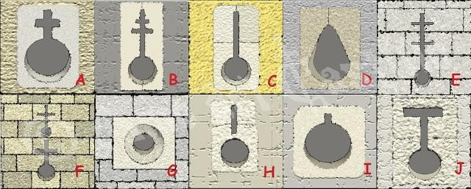

On the corners of the flanking towers, the supports of the machicolations have been preserved, on which a kind of "box" of stone was anchored, which protruded from the corners, and which allowed a view, since the ground was perforated, without being in danger of being reached by enemy fire.

Do you dare to draw them?

BOMBARDS
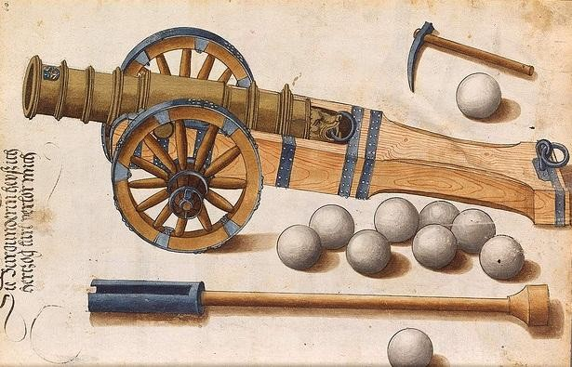
The bombard or Lombard, currently considered the oldest portable firearm of all, was a very primitive piece of artillery that would end up being the precursor of the cannon.

The bombards were built of staves and wrought iron rings. They were composed of cane and false chamber, which were joined together with roughly affixed ropes. They were of very short length of bore and shot as a roughly carved stone sphere.

Soon, however, they were made longer and, at the end of the 14th century, an important progress was made when the stone sphere or ‘bolaño’ began to be replaced by the cast iron one, which allowed the calibre to be reduced.

How many stone balls or ‘bolaños’ can you add up to?

GRAPHITES ON STONE

As is the case today, medieval workers were tempted to print on fresh cement whatever they could think of. Among these graphites you can see different types of boats, geometric figures, indications to the workers of constructive type, faces, phrases and scribbles of all type and difficult interpretation. One of these phrases, however, leaves little room for interpretation because its purpose is clear: "Byua el duq" which is transcribed "Viva el Duque”. This way the workers demonstrated their adherence and sympathy to the lord.
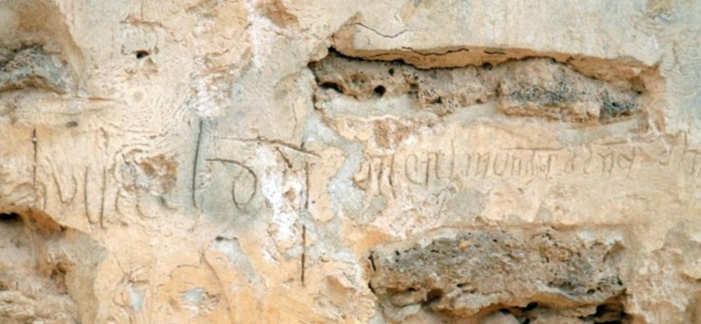

Would you be able to find their location?

SIREN DOORWAY

Both Enrique de Guzmán and his wife, Doña Leonor de Mendoza, always showed a great interest in art and new Renaissance trends, so they did not miss the opportunity to show it in their building. The door of the Siren takes its name from the relief that decorates it. It is a mythological marine animal, probably a mermaid whose forked tail protects the coats of arms of the Duke of Medina Sidonia (left), and of the Duchess Doña Leonor de Mendoza (right). Flanking the entrance, two big axes (segures) can be seen in relief, a personal symbol of the

Duke Don Enrique. Segur comes from Latin and means "safe" or "safe from danger". This fits with the lettering that was the Duke's motto:

"The most dangerous things with me ensure their danger."

PARADE GROUND

Both for the defence of the castle and for daily and domestic life, transit areas were necessary, of which the main one was the parade ground. During the first years of the castle, the central
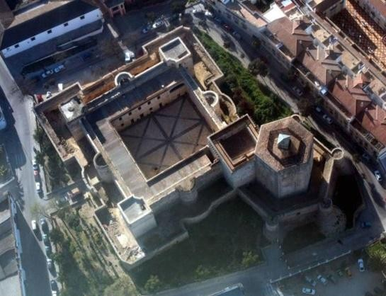
courtyard was porticoed in the style of other castles of the time, probably in the proto-Renaissance style. However, the fact that the castle remained in military use beyond the Middle Ages meant that this courtyard soon disappeared.

At this point of the tour you can take advantage of the opportunity to recover your strength by having a snack.

AULA MAIOR

This room was the most ostentatious place in the castle. Duly decorated and illuminated, it must have served to impress the visitor, and it must have been the place to receive the illustrious (ambassadors, other lords, people of quality, princes, kings...). In the pendentives of the dome are preserved remains of the paintings that decorated this space, representing again the ‘secures’ of the II Duke Don Enrique de Medina Sidonia. The dome was panelled.

What is the shape of this symbol? Write it down in the notebook.

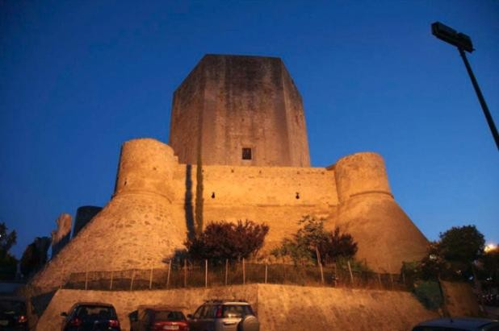
TOWER OF HOMAGE

The Homage Tower is the strongest, most outstanding and main tower of a castle. It is also the one that used to be inhabited by the lord when he visited the castle or its mayor in his absence. In Santiago, we know that our dukes lived little in the tower, except in certain circumstances that demanded a

certain amount of prudence. Originally, the ceremonies of homage that linked the lord and the vassal in feudal times were held there, as well as serving as a hall of justice or a space reserved for various social events.

The tower has a supply well, an unusual element, which is a hole that runs through the centre of the tower's staircase, originally intended to facilitate the transfer of water, ammunition and other useful things. We must bear in mind that, in medieval castles, where rooms had few windows and darkness predominated, these openings used to be the point with the most light and therefore the only place where any activity requiring a certain natural light could be carried out.

The roof of the tower can be visited and from there you will be able to contemplate one of the best views of this wonderful city.

Indicate on the map where it is located. Around the castle there is a second, lower wall called the barbican, which serves to reinforce its defensive character.

COSTUME MUSEUM
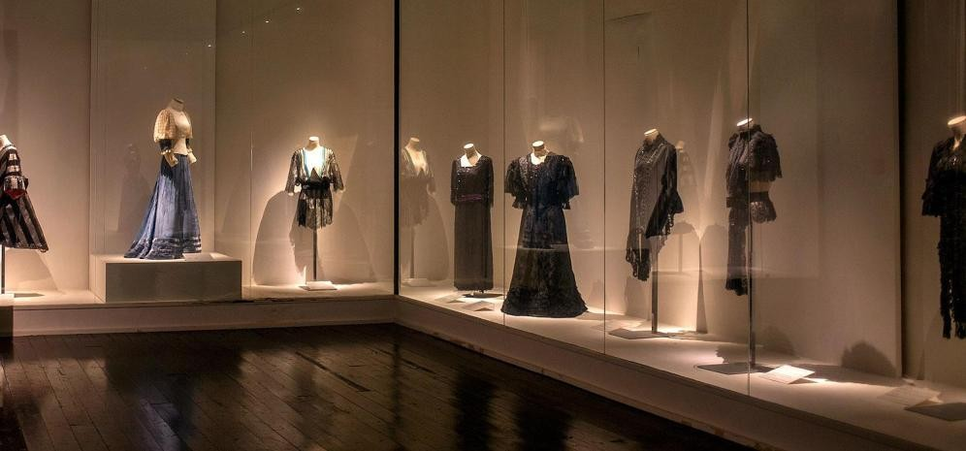

The Costume Museum "Taboada de Zúñiga Collection" offers a very illustrative vision of the history of clothing and the transformation it has undergone from the end of the 18th century to the first decades of the 20th century. These pieces require special conservation conditions due to their fragility. One of the missions of the exhibition is to preserve them from external agents that may deteriorate them. For this reason, in order to preserve the garments in optimal conditions, the rooms require very low levels of light. The weapons kept in this exhibition show the evolution from 17th century hand daggers to late 19th century military sabers. These are unique examples, many of which were made by important craftsmen from different periods.

Which one would you choose to wear?

Once we leave the castle, we go along Luis de Eguilaz Street towards the Plaza de la Paz. In this street it is located the old convent of the Jesuits (17th-18th century). The church is now a wine cellar and the convent's rooms have been adapted for housing. In front of the convent there is another cellar that was originally the Casa Cilla (18th century), which was the place where the tithe was deposited (it consisted of paying the church a tenth of the harvest in kind).

PLAZA DE LA PAZ (PEACE SQUARE)

It was the centre of the medieval city, where the Muslim Castle of the Seven Towers was located, the origin of the current Sanlúcar, and was the starting point for the streets that went to each of the gates that opened in the walls: Puerta de Sevilla (1), Puerta de Jerez (2), Puerta de la Fuente (3) and Puerta del Mar (4). Some of the most important buildings in the city were also located here: Casas del Cabildo (Town Hall), Pescadería Pública (Public Fish Market), Pósito (grain warehouse), Iglesia Mayor (Main Church) and Palacio Ducal (Ducal Palace).

STAND in front of the main façade of the CHURCH OF OUR MRS. Construction began in the 14th century. The lower part of its tower belonged to the old Muslim castle of the Seven Towers. In the 17th century the current body of bells was added. If you observe its cover and you compare it with those represented in this scheme, which one do you identify it with?
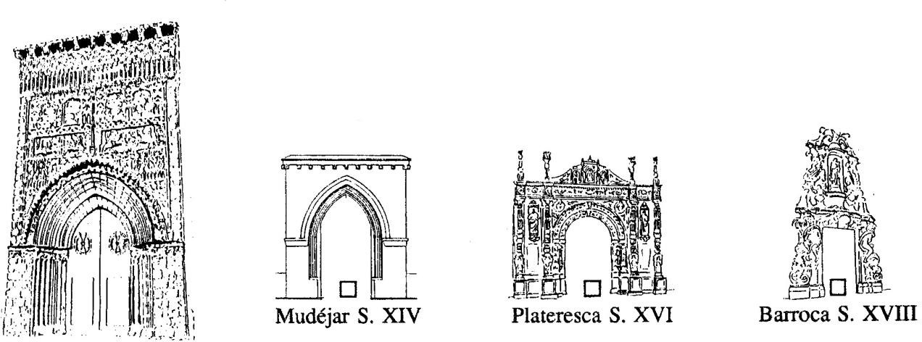

Of all these architectural and decorative elements that we present to you below, mark those that you can locate on the cover:
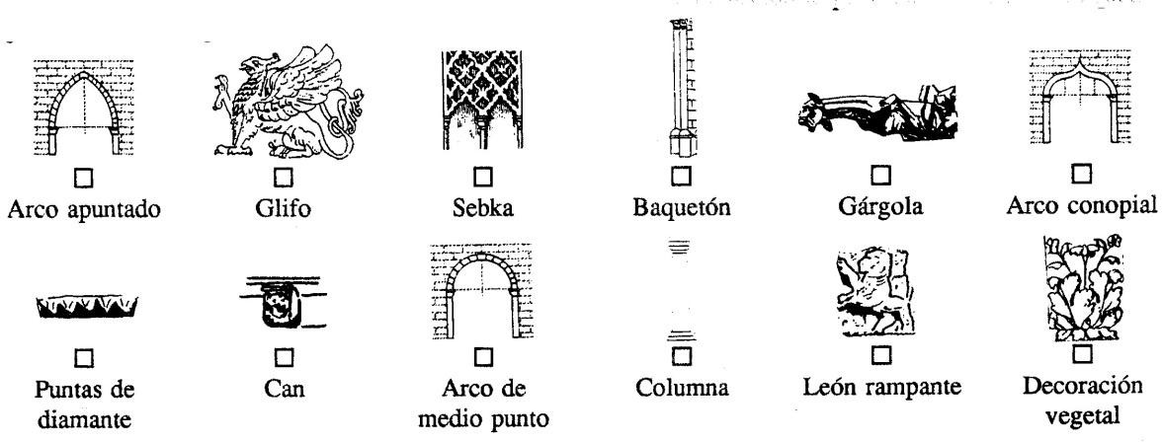

El mudéjar se caracteriza por mezclar elementos de arquitectura cristiana (ar conopiales, apuntados, baquetones, escudos, etc.) con otros de tradición musulmana (arcos polilobulados, decoración de sebka,etc.)

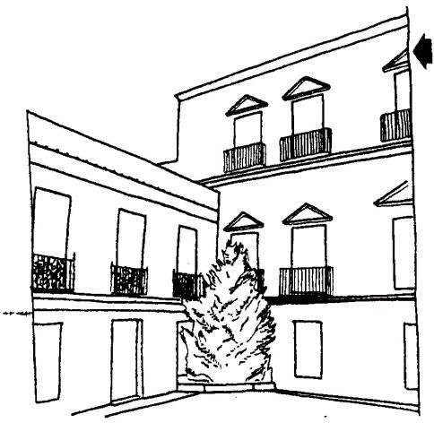
ON OUR LEFT we are in front of the façade of the MEDINA SIDONIA DUCAL PALACE (16th century), which we see behind a grille, next to the main façade of the Church of the
O. Like it, it is located over the old Castle of the Seven Towers.

This palace is the result of multiple extensions and reforms carried out over centuries of existence. It is still the residence of the ducal family and preserves not only a rich artistic heritage but also an important documentary heritage, consisting of an archive where the documents of
the multiple activities of this important family are kept, which help us to know our history better.

In its main facade, we can observe its simplicity, organized according to a balanced composition of openings, with a clear Italian classical influence, with three fronts to a common courtyard separated from the outside by a grille and iron gate. The façade is three storeys high in the central section facing the access street, and two storeys on the sides; and its only decoration is the triangular pediments of the front openings, plus the shield of the Ducal House carved in stone located on the right, next to the main entrance to the palace. Worthy of mention is the large central grille, a valuable 15th century Gothic-Renaissance piece from the ducal palace in Seville.
Draw here its facade or parts of it.

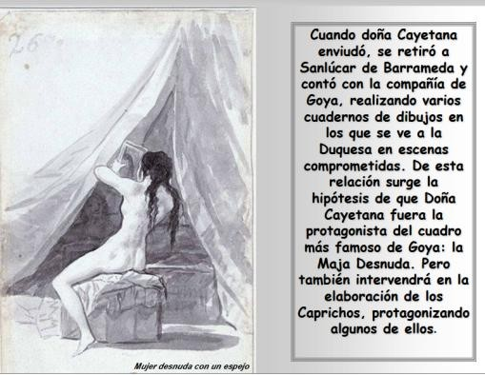
Prominent historical figures such as King Philip V, The Duchess of Alba (s. XVIII) and the painter Francisco de Goya were invited to this palace by the Dukes. There, it is thought that the artist could have painted his work "La Maja".

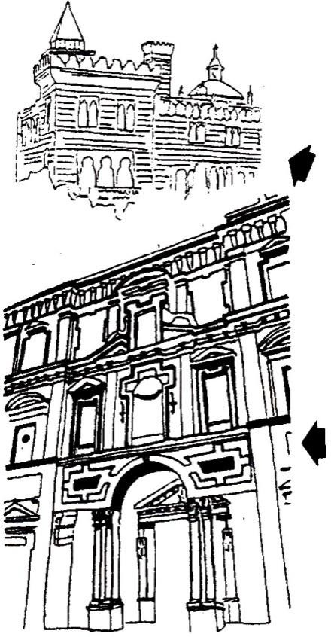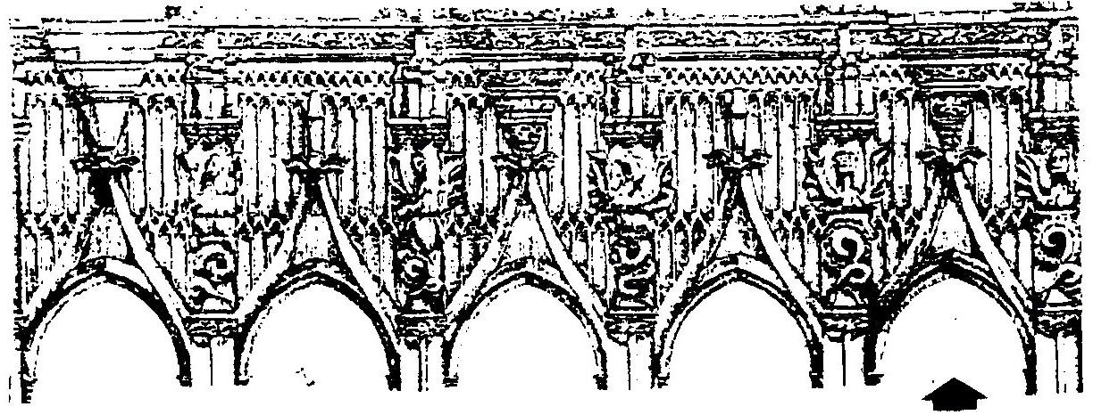
We continue along Caridad Street towards Caballeros Street to go to the PALACE OF THE DUCHES OF ORLEANS-BORBÓN, the
current headquarters of the Town Hall, which was built using the premises of the Convent of La Merced. Its exterior is neo-Mudejar (a return to the elements typical of Mudejar), corresponding to the architectural tastes of the late nineteenth century, so you can see in it arches and balconies that imitate Islamic architecture.

Next to this palace, on the Cuesta de Belén, it is the church of the former CONVENTO DE LA MERCED (17th century), a work in which Alonso de Vandelvira also participated along with Juan de Oviedo, another important architect of the time. Through the grille located at the compass door, the space where the convent and church door used to be, you can see the main façade of the convent where many of the classic elements of the architecture of the time are present.
Advancing along the Cuesta de Belén we pass LAS COVACHAS (15th century), whose layout coincides with that of the medieval wall of the walls, the Puerta del Mar (Sea Gate) having been located in this area. The reason for its construction is not clear and there are different opinions about its origin. Some believe that it may have belonged to the Doge's Palace, others that it may have been part of the old Sea Gate.
Whatever its primitive function was, we face a monument of great interest because it is one of the few examples of civil Gothic architecture in our province. Among the arches, there are sculptures of monsters, frequent elements in Spanish architecture at the end of the 15th century as a possible reflection of fantastic stories told by sailors.

Draw in this box the figure you choose.

